Steps to install device driver for android phones which are not detected in eclipse for development and debug.

Pre-requisite: download the google usb driver using Android SDK Manager.

1. Open device manager and get the device id’s from other devices properties.
2. It would look like:

USB\VID_18D1&PID_D002&REV_0232  
USB\VID_18D1&PID_D002

1. Copy those two values and prepend with

%SingleAdbInterface% = USB_Install,

%CompositeAdbInterface% = USB_Install,

1. Add generated line like shown below in to **android_winusb.inf** from the device driver folder.

%SingleAdbInterface% = USB_Install, USB\VID_18D1&PID_D002&REV_0232  
%CompositeAdbInterface% = USB_Install, USB\VID_18D1&PID_D002

1. Now update the driver and give the driver path from the location where driver is downloaded. You will get the screen as shown as we modified the inf file. Install anyway and starting using the device.

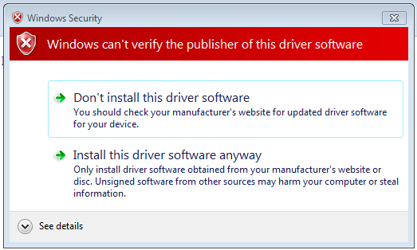

The device would be detected and can see the logs in eclipse logcat view.